I know they were caught because I was there.
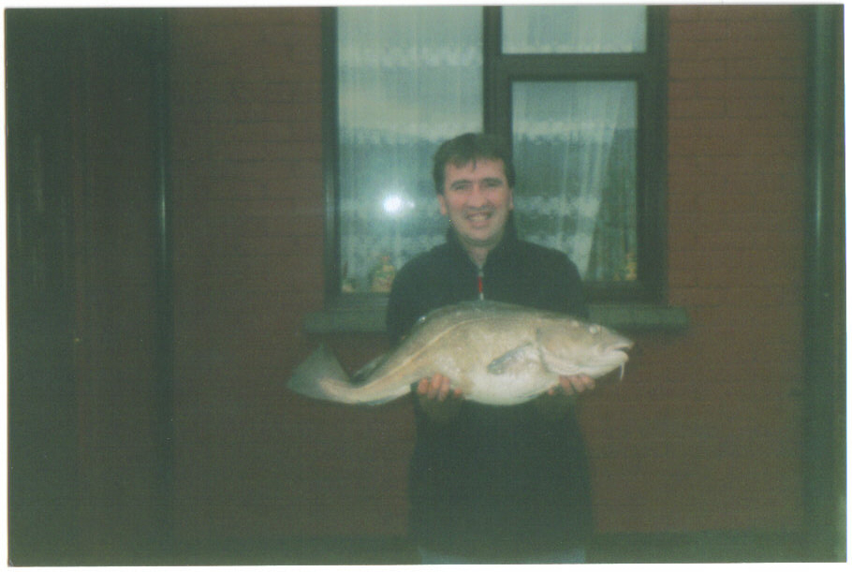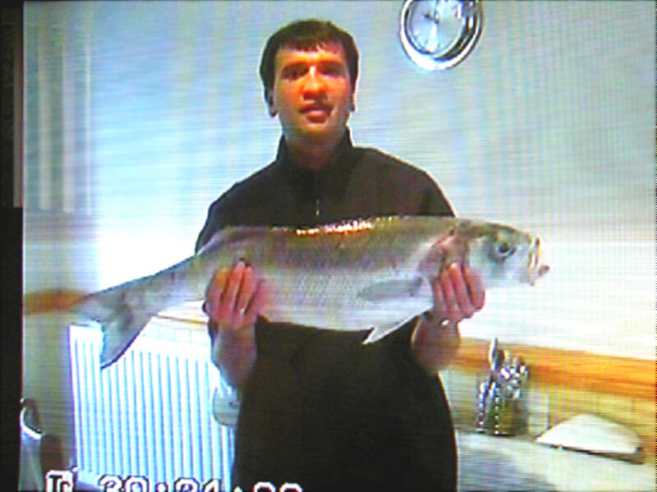
A near 12lb Cod from Kilve with and S 12lb 3oz super Bass taken from Lillstock flats on Whole Squid
Shaped tail. Super- fish. Photo taken from a camcorder hence the quality.

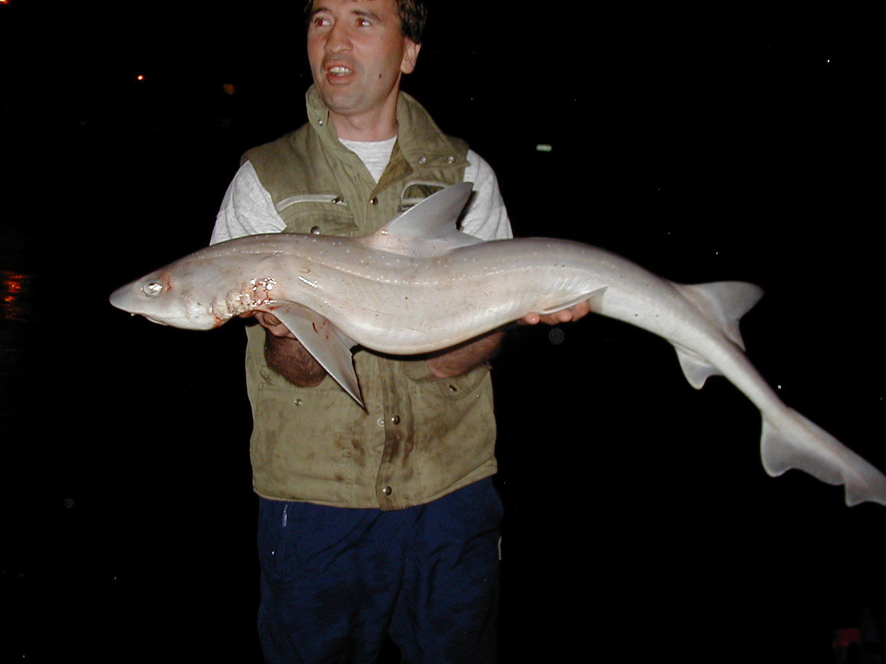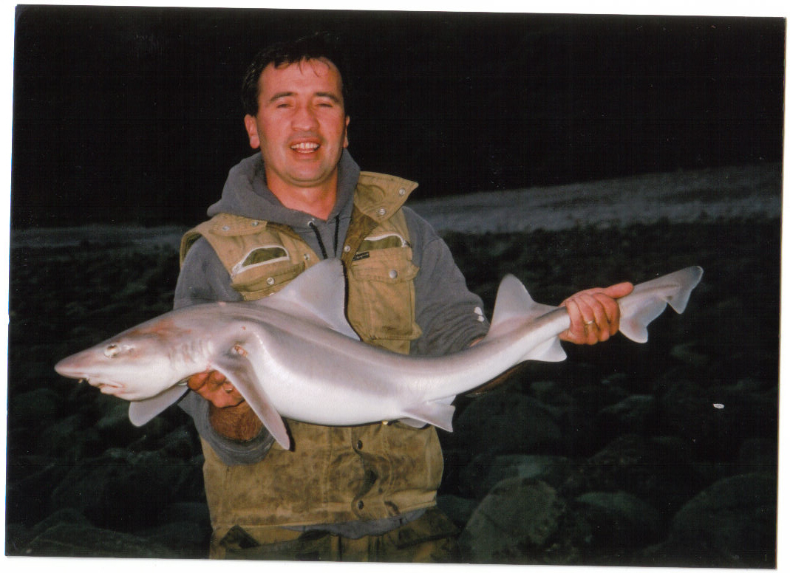
13lb 6oz Starry from Gas works one of the A massive common from Emberwood taken on Crab
first caught there. Taken on squid and black lug. 13lb 8oz. Both hound won best of species at the BCFSA
Now common along this venue. Awards as did the Bass.

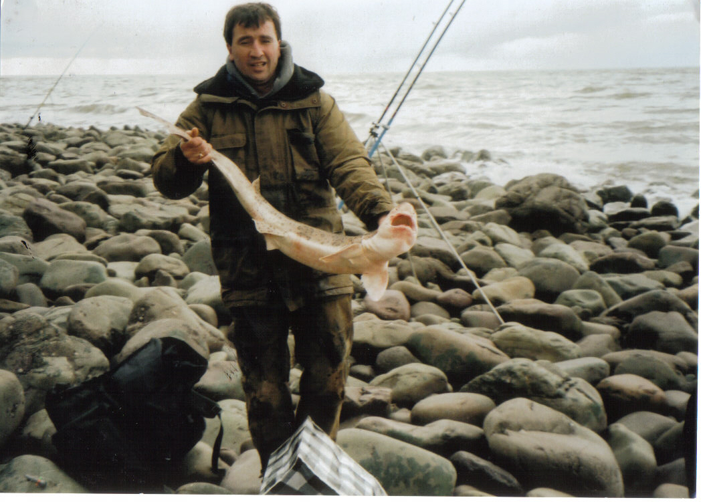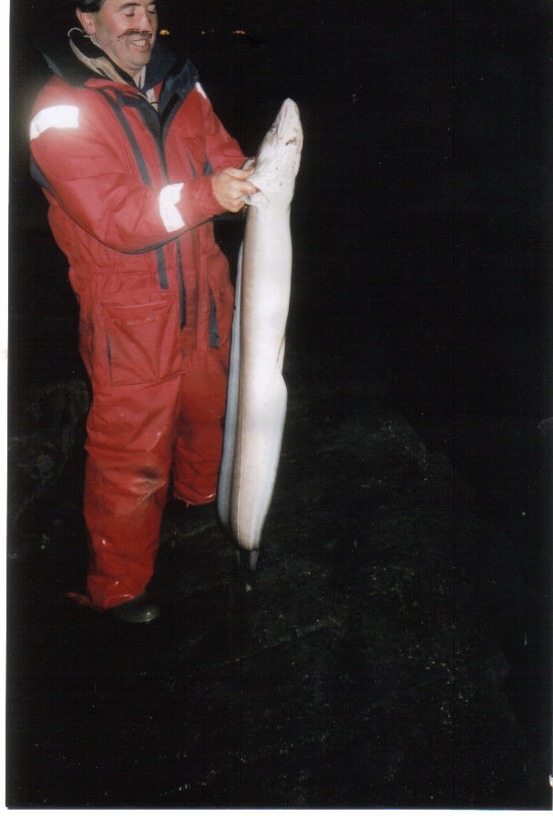
Another Emberwood stunner a 13lb 8oz Bull In some ways my most amazing feat. I landed this fish with
Huss and the b…gger bit me. Taken on The help of Spencer and big Rob from Shurton on my Bass
Cuttlefish. Rod, 10lb main line and 30lb leader. It weighed 21lb 6oz.

